Linux Basics Commands **Tasks**

1. File System Navigation:
   1. Navigate to your home directory.

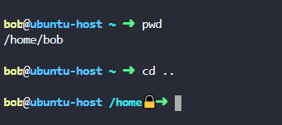

* 1. List all files and directories in your home directory.



1. Creating and Removing Directories:
   1. Create a directory named "projects".
   2. Navigate into the "projects" directory.

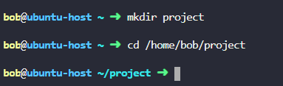

* 1. Create a subdirectory named "project1".

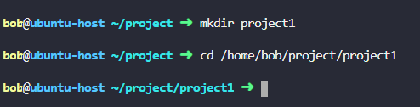

* 1. Remove the "project1" directory.

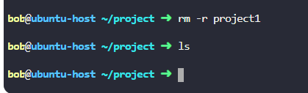

1. Creating and Removing Files:
   1. Navigate back to your home directory.
   2. Create a file named "notes.txt" using the touch command.

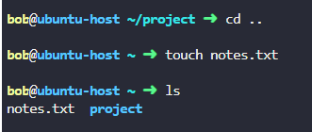

* 1. Remove the "notes.txt" file.

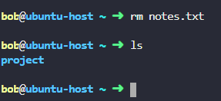

1. File Manipulation:
   1. Create a new file named "list.txt".



* 1. Open "list.txt" using a text editor like nano or vim.



* 1. Add some text to "list.txt" and save the changes.

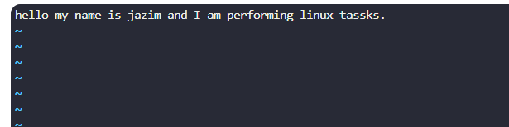

* 1. View the contents of "list.txt".



1. Copying and Moving Files:
   1. Create a copy of "list.txt" named "list_backup.txt".

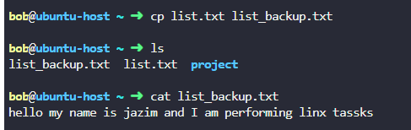

* 1. Move "list_backup.txt" to the "projects" directory.

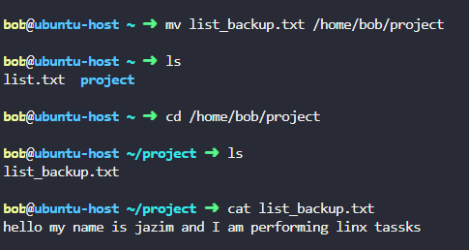

1. Viewing File Contents:
   1. View the first 5 lines of "list.txt".

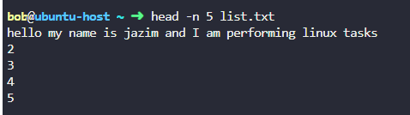

* 1. View the last 10 lines of "list.txt".

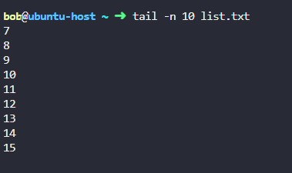

1. Permissions:
   1. Check the permissions of "list.txt".



* 1. Change the permissions of "list.txt" to make it readable, writable, and executable by the owner only.

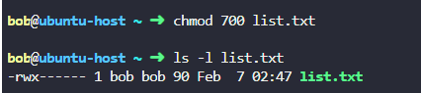

1. Process Management:
   1. View the list of running processes.

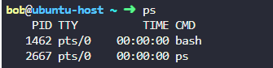

* 1. Find a specific process and terminate it.

**Kill -9 PID**

1. System Information:
   1. Display the current date and time.



* 1. Print the system's hostname.



1. Package Management:
   1. Update the package list using the package manager.

